

**Project Name: Daily Needs**

**Batch PG-DAC Sep-2021**

Submitted By

**Group No: 22**

* 210943120087 Pratik Sawant
* 210943120078 Rahul Memane
* 210943120104 Soni Kumari
* 210943120046 Kunal Mahajan

**UNDER THE GUIDENCEOF:**

Mrs. Harshita Maheshwari

Faculty Member

**Infoway Technologies, Pune.**

**Table of Content:**  
**1. Introduction**  
           1.1. Problem Definition  
           1.2. Objective of Project  
**2. Feasibility Study**  
**3. Analysis**                                  
           3.1. Existing System                                    
           3.2. Proposed System                                    
           3.3. Software Requirement Specification  
**4. Design**                                    
           4.1. UML diagrams                                    
**5. Implementation**  
           5.1. Modules  
           5.2. Module description  
           5.3. Introduction of technologies used  
**6. Test cases**  
**7. Screenshots of Webpages  
8. Conclusion  
9. Future Enhancement  
10.  Bibliography**

1. **Introduction of Project:**

**1.1. Problem Definition**

The business of local shops is badly affected due to online shopping, so main purpose of our project is to give a platform to increase their business.

Daily Needs App provides its users with the best offers on **offline shopping & Online Shopping.**

This local market has made our lives very easy as all day-to-day items are available at a comfortable distance. The shopkeepers are honest and sell quality products at reasonable prices.

Get daily discounts and coupons on local shops near your location

**Ex.- Grocery, Vegetables, Dairy Products& more**. ...

**1.2. Objective of Project**

* End users can compare a lot of products from different local shops in single application.
* Due to easy comparisons, end users can buy their products with best possible offers.
* One more benefit for end users is that they can directly contact the shopkeepers for shopping and may get home delivery if available on local shops.

**2. Feasibility Study**

The feasibility study of this project comprise of the following

**Economic Feasibility**

The cost centers in the system development as well as operation are trivial. The major can be network, internet and the software required for coding. The software used for the development of the proposed system is PHP and MySQL. In terms of wallet our product is in well reach of pocket.

**Technical Feasibility**

Technical feasibility centers on the current system and to what extent it can support the proposed system, it includes current computer system specifications such as hardware, software etc. it also involves financial considerations to accommodate the technical enhancements. If the budget is serious constraint then the project is judged not feasible.

Though the system is developed in the generalized form, which covers all the procedures and operations carried out in an internet based solution. The version used in the system is PHP and MySQL.

MySQL can manage large amount of data and is simple and secure. Using PHP helps us to design the look of our application.

**Operational Feasibility**

In this we determine what change will be brought in system, new skills required and other human organization and political aspects.

Each user can easily use our site. However it is desirable that the user has the basic knowledge of the computers.

Without making any changes in the rules and regulations of the existing system proposed system can easily adopted.

**3. Analysis**

**3.1. Existing System**

The present scenario for shopping is to visit the shops and market manually and then from the available product list one needs to choose the item he or she wants and then pay for the same item mainly in cash mode is done, as not every society is well educated and aware to use net banking or card modes or wallets etc.

This system is not much user-friendly as one needs to go to the market physically and then select items only from the available list. So mostly it is difficult to get the product as per our desire. Description About the products is less available and are mostly verbal only. For this type of shopping, one needs to have an ample amount of free time.

Also, not really good markets exist everywhere, so many times good markets become out of reach for certain people. In the proposed system customers need not go to the shops for purchasing the products. He/she can order the product he/she wishes to buy through the use of this system. The shop owner can be the admin of the system.

The shop owner can appoint officials particularly to handle this, who will help the owner in managing the customers and product orders. The system also endorses a home delivery system for delivering the purchased products.

**3.2. Proposed System**

**1) Immediate retrieval of information**

The main objective of the new system is to provide for quick and efficient retrieval of information. Any type of information would be available to the user whenever he requires. Facility would be provided for online query to cut down on the response time greatly.

**2) Immediate storage of information**

In the proposed system, it will be easy to store information at any given time at the correct places. The location of storage would be easily available and user will face no difficulty.

**3) Prompt updating of information**

In the proposed system, the information will always remain up to date as the updating will be prompt and without any efforts. This factor will be of great importance in the proposed system as it determines the integrity of the information stored.

**4) Fast computation of information**

The computation of information will be quite fast in the proposed system. Not only mathematical calculations, but also logical comparisons will be quick in the new system.

**5) Planned approach toward working**

The working in the service center information system will be well planned and organized. The data will be stored properly in the data store, which will help in retrieval of information as well as in its storage.

**6) Generation of managerial and strategic reports**

The new system would provide for regular generation of reports, which would help the management in decisions making work and in controlling the overall working of the organization. The generation, of these reports would be possible only if the system is organized such that retrieval of information can be made on conditions.

**7) Accuracy**

The level of accuracy in the new proposed system would be higher. All operations and computations would be done correctly and this will ensure that whatever information is coming from the center, it is accurate.

**8) Reliability**

The reliability of the proposed system would be high due to the above stated reasons. The reason for the increased reliability of the system is that now there would be proper storage of information, its maintenance would be well managed and retrieval would be possible in the desired manner.

**9) Non Redundant Information**

In the new system, utmost care would be taken that no information is repeated, any usage of storage or otherwise. This would assure economic usage of storage or space and consistency in the data stored. This will also help make those changes easily as the change would have to be made only at that very place and no where else.

**3.3. Software Requirement Specification   
Hardware:**

1. Intel i3 processor 3 rd generation or later / AMDRyzen2002ndgeneration or later
2. 2 GB ddr3 ram
3. Windows 7 Home edition or later
4. 200 GB Sata HDD Space
5. Data Connection 200 Kbps

**Software:**

1. Eclipse EE 2020-21
2. MySQL 5.7 with Workbench 8.0
3. Google Chrome version 79.0
4. Apache Tomcat Server 8.5

5. Maven Dependencies

**4. Design**

**4.1. Data Flow Diagram**

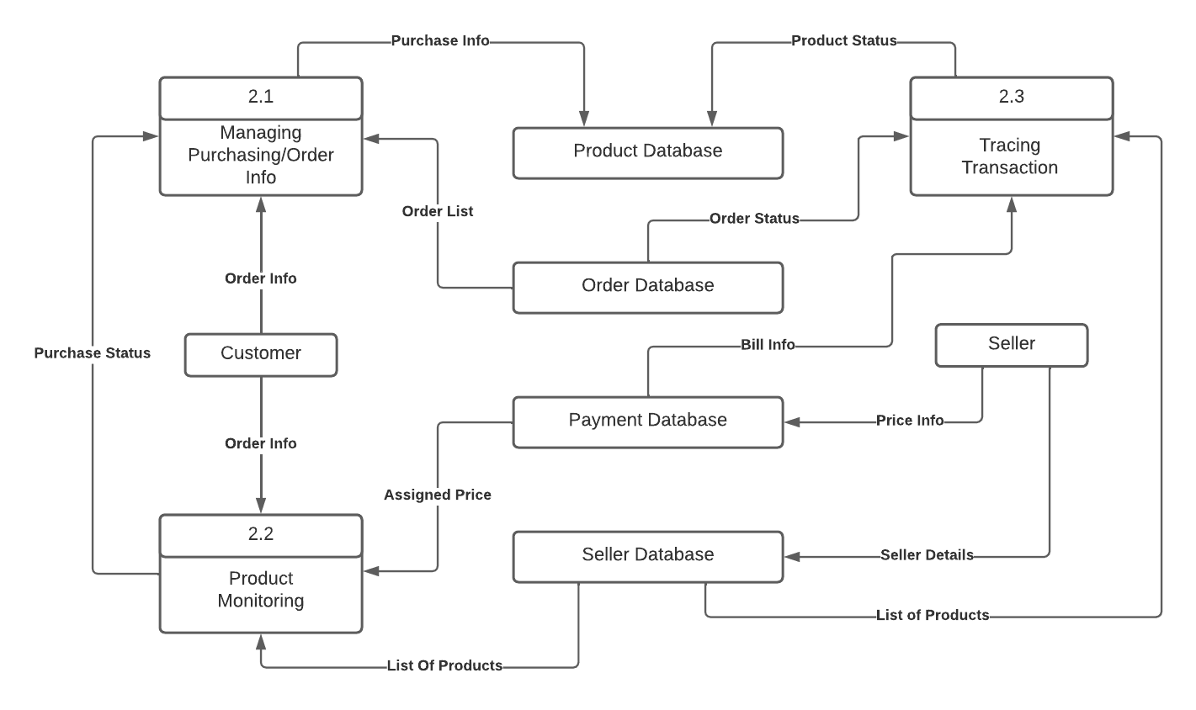

**4.2. ER Diagram**

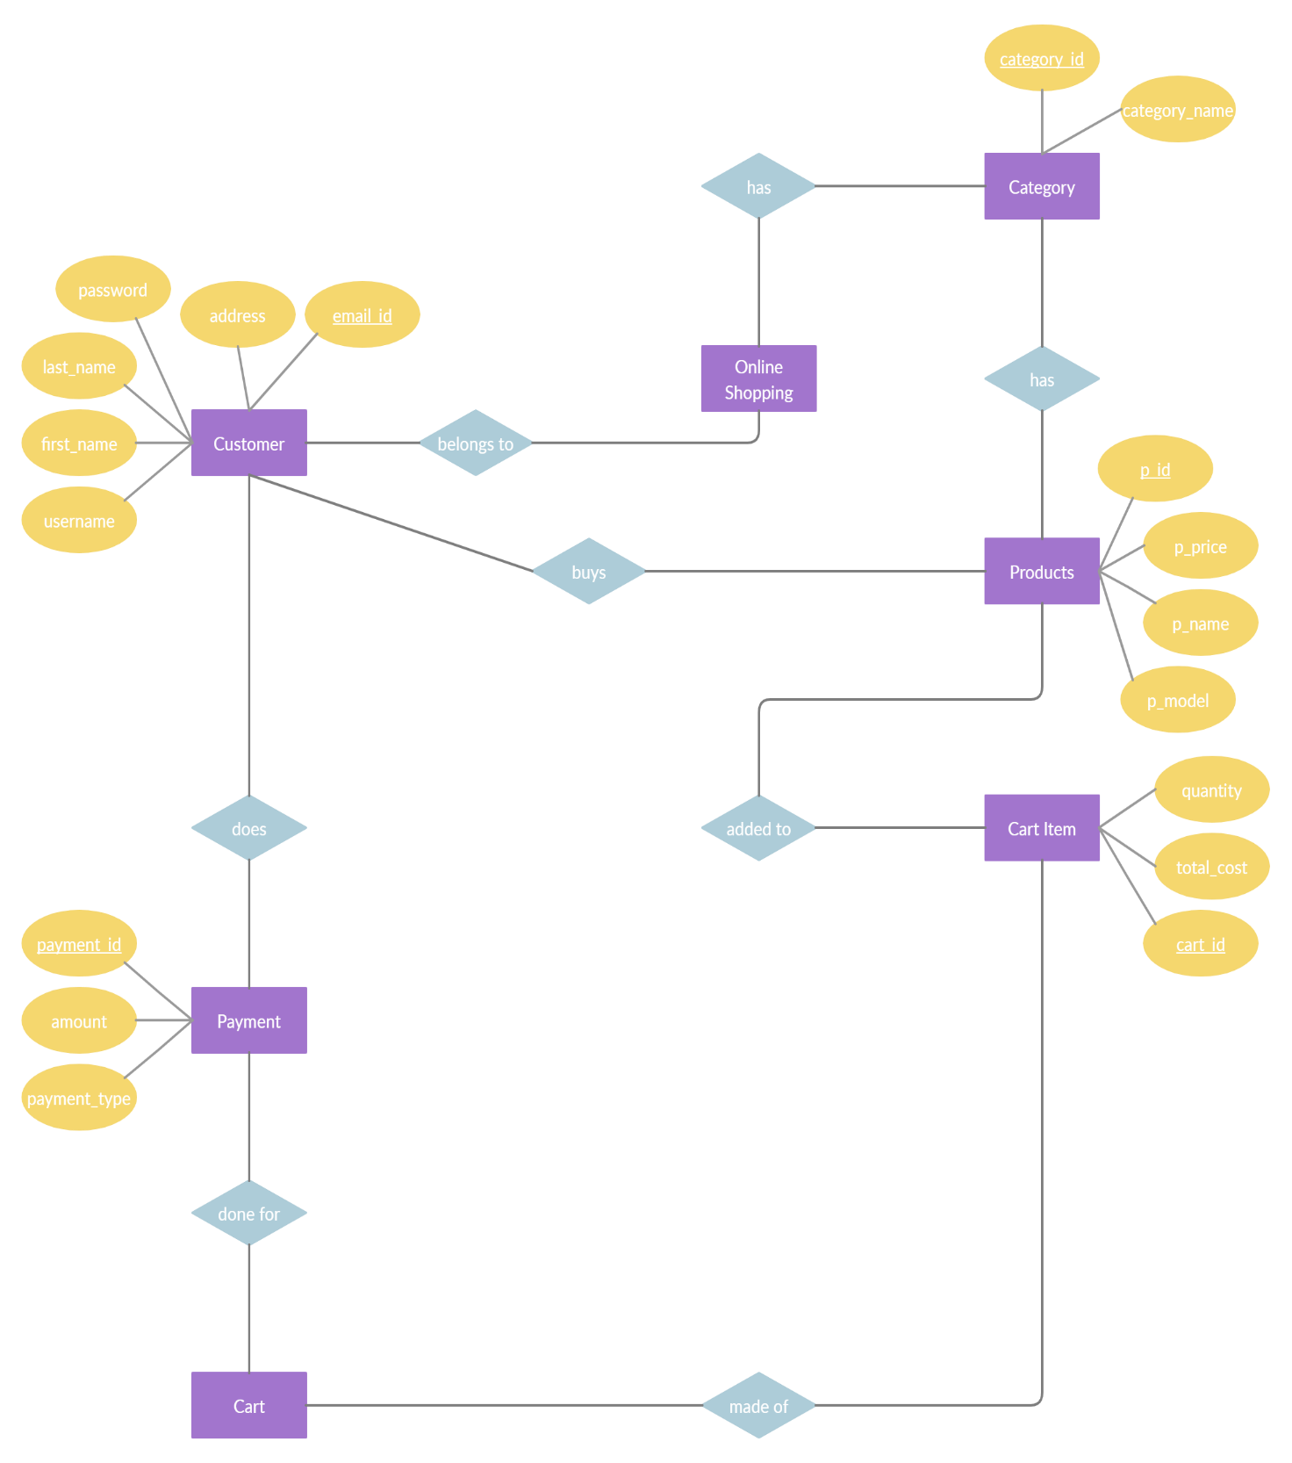

1. **Implementation**

**5.1. Modules**

**1.Admin**

**2.Shopkeeprs**

**3.Customer**

**5.2. Module description**

**5.2.1 Admin**

1.Merchant registration management

2.Product approval

3.Billing Management

4.Full access to customer information (email, browsing/purchase history)

**5.2.1 Shopkeeper**

1.Register to the website.

2.Log in to your Merchant Center account.

3.Select Products from the navigation menu, then click All products.

4.Click the plus button to add a product.

5.Fill in the required product data fields.

(Optional) If you sell similar products which vary by colour, size, gender or other variant attributes, go to the 'Detailed product description' section and click I have grocery and dairy products. You can add all variant colours, genders, age groups, sizes, materials and patterns for the product. Choose the attributes and corresponding attribute values which distinguish your variant items.

**5.2.3 Customer**

1.Register on website.

2.Search Products and offers.

3.Can order product.

4.Can visit shop and purchase the product.

5.The Post-Purchase Phase(return policy).

**5.3. Introduction of technologies used**

**5.3.1 Spring Boot Framework:**

Spring Boot provides a good platform for Java developers to develop a stand-alone and production-grade spring application that you can just run. You can get started with minimum configurations without the need for an entire Spring configuration setup.

Spring enables you to build applications from “plain old Java objects” (POJOs) and to apply enterprise services non-invasively to POJOs. This capability applies to the Java SE programming model and to full and partial Java EE.

**Features of Spring boot Framework:**

**Web Development**

It is well suited Spring module for web application development. We can easily create a self-contained HTTP server using embedded Tomcat, Jetty or Undertow. We can use the spring-boot- starter-web module to start and running application quickly.

**Spring Application**

It is a class which provides the convenient way to bootstrap a spring application which can be started from main method. You can call start your application just by calling a static run () method.

**Admin Support**

Spring Boot provides the facility to enable admin related features for the application. It is used to access and manage application remotely. We can enable it by simply using spring.application.admin. Enabled property.

**Logging**

Spring Boot uses Common logging for all internal logging. Logging dependencies are managed by default. We should not change logging dependencies, if there is no required customization is needed.

**Security**

Spring Boot applications are spring bases web applications. So, it is secure by default with basic authentication on all HTTP endpoints. A rich set of Endpoints are available for develop a secure Spring Boot application.

**Advantages of a Spring Boot application**

* Fast and easy development of Spring-based applications
* No need for the deployment of war files
* The ability to create standalone applications
* Helping to directly embed Tomcat, Jetty, or Undertow into an application
* No need for XML configuration
* Reduced amounts of source code

**The JDBC Template**

The central class of the Spring JDBC abstraction framework is the Jdbc Template class that includes the most common logic in using the JDBC API to access data, such as handling the creation of connection, statement creation, statement execution, and release of resource. The Jdbc - Template class can be found in the org.springframework.jdbc.core package.

The Jdbc Template class instances are thread-safe once configured. A single Jdbc Template can be configured and injected into multiple DAOs. We can use the Jdbc Template to execute the different types of SQL statements. Data Manipulation Language (DML) is used for inserting, retrieving, updating, and deleting the data in the database such as SELECT, INSERT, or UPDATE statements

**5.3.2 MySQL**

MySQL, the most popular Open-Source SQL database management system, is developed, distributed, and supported by Oracle Corporation.

**Features of MySQL:**

A database is a structured collection of data. It may be anything from a simple shopping list to a picture gallery or the vast amounts of information in a corporate network. To add, access, and process data stored in a computer database, you need a database management system such as MySQL Server. Since computers are very good at handling large amounts of data, database management systems play a central role in computing, as stand alone utilities, or as parts of other applications. •

**MySQL databases are relational.**

A relational database stores data in separate tables rather than putting all the data in one big storeroom. The database structures are organized into physical files optimized for speed. The logical model, with objects such as databases, tables, views, rows, and columns, offers a flexible programming environment. •

**MySQL software is Open Source.**

Open-Source means that it is possible for anyone to use and modify the software. Anybody can download the MySQL software from the Internet and use it without paying anything. The MySQL Database Server is very fast, reliable, scalable, and easy to use. MySQL Server works in client/server or embedded systems. The MySQL Database Software is a client/server system that consists of a multithreaded SQL server that supports different backends, several different client programs and libraries, administrative tools, and a wide range of application programming interfaces (APIs).

**5.3.3 React JS**

React JS is JavaScript library used for building reusable UI components. According to React official documentation, following is the definition−React is a library for building composable user interfaces. It encourages the creation of reusable UI components, which present data that changes over time. Lots of people use React as the Vin MVC. React abstracts away the DOM from you, offering a simpler programming model and better performance. React can also render on the server using Node, and it can power native apps using React Native. React implements one-way reactive data flow, which reduces the boiler plate and is easier to reason about than traditional data binding.

**React Features**

* **JSX** − JSX is JavaScript syntax extension. It isn't necessary to use JSX in React development, but it is recommended. •
* **Components** − React is all about components. You need to think of everything as a component. This will help you maintain the code when working on larger scale projects. •
* **Unidirectional data flow and Flux** − React implements one-way data flow which makes it easy to reason about your app. Flux is a pattern that helps keeping your data unidirectional. •
* **License** − React is licensed under the Facebook Inc. Documentation is licensed under CC BY 4.0.

**React Advantages**

Uses virtual DOM which is a JavaScript object. This will improve apps performance, since JavaScript virtual DOM is faster than the regular DOM. Can be used on client and server side as well as with other frameworks. • Component and data patterns improve readability, which helps to maintain larger apps.

**6. Test cases**

|  |  |  |  |  |  |
| --- | --- | --- | --- | --- | --- |
| **Test case id** | **Test case Name** | **Test case description** | **Expected Result** | **Actual result** | **status** |
| 1 | Registration of customers | Customer can register by filling in required details | On successful registration, customer will be directed to the login page. | Customer is directed to the login page. | successful |
| 2 | Registration of Vendor | Vendor can register by filling in required details | On successful registration, Vendor will be directed to the login page. | Vendor is directed to the login page. | successful |
| 3 | Admin Login | Admin needs to enter his email id and password for login | Admin can see his homepage | Admin is on his home page | successful |
| 4 | customer Login | Customer need to register first and then enter his Email and password for login. | Customer can see his homepage | Customer is on his home page | successful |
| 5 | Vendor Login | Vendor need to register first and then enter its Email id and password for login. | Vendor can see its homepage | Vendor is on his home page | successful |
| 6 | Order Product | Customers will Order product as per their requirements | After product Order customer will | Customer is on payment page | successful |

**7. Screenshots of Webpages**

**Home Page**

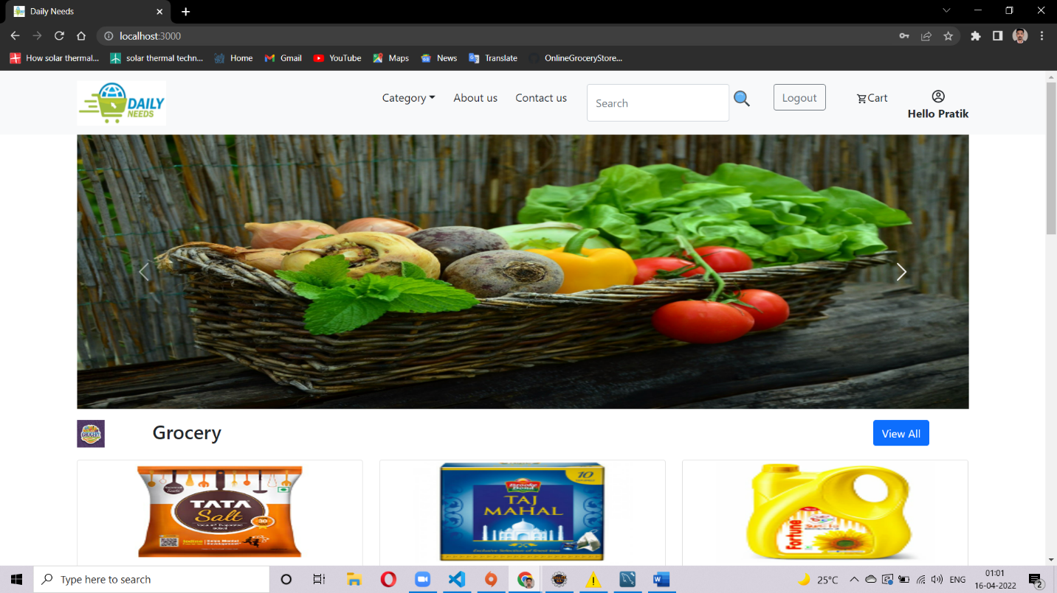

**Login Page**

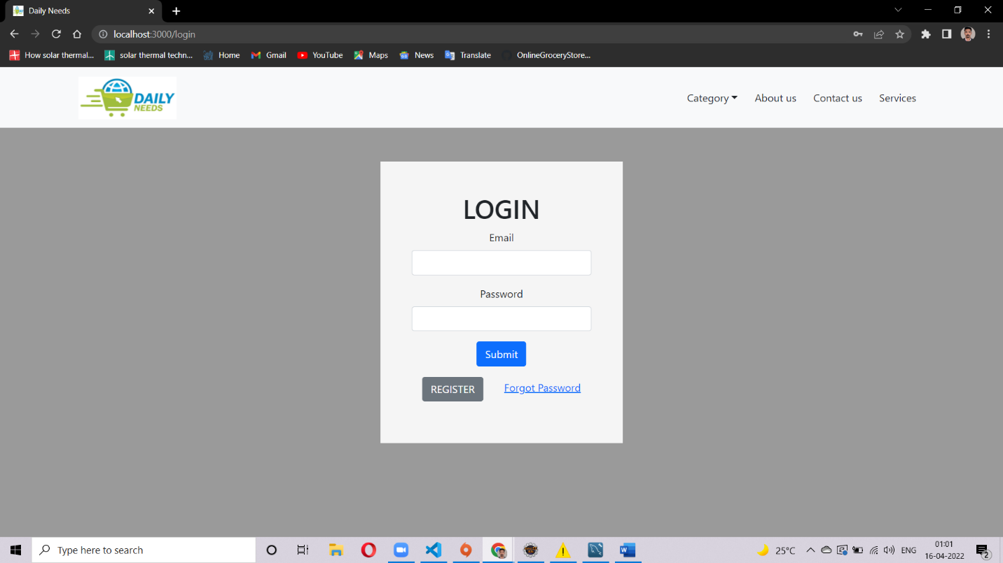

**Registration Page**

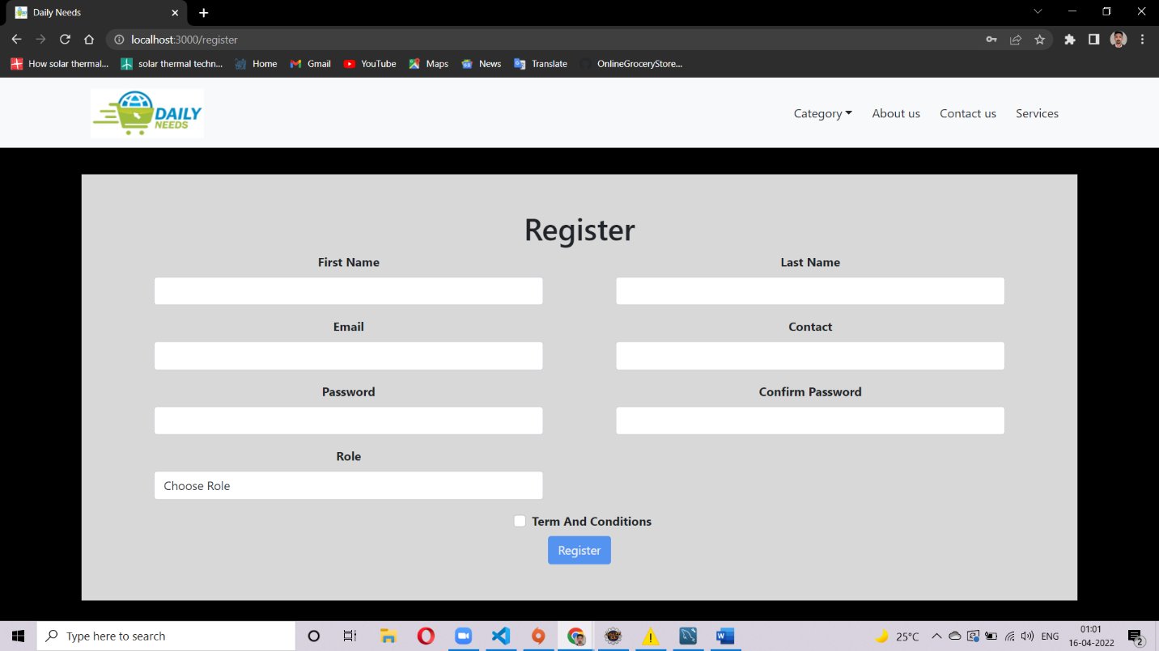

**Vendor Page**

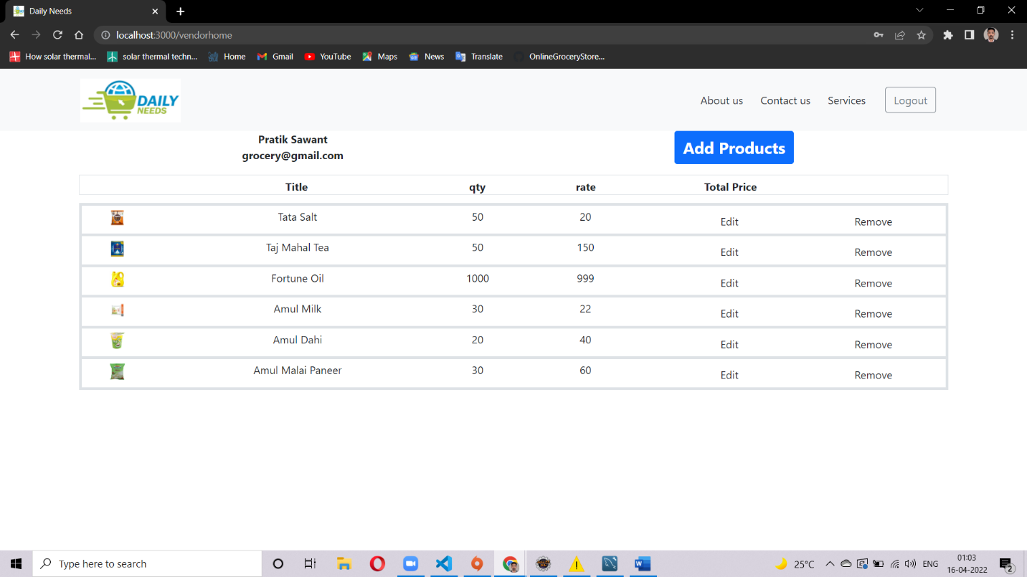

**Customer Page**

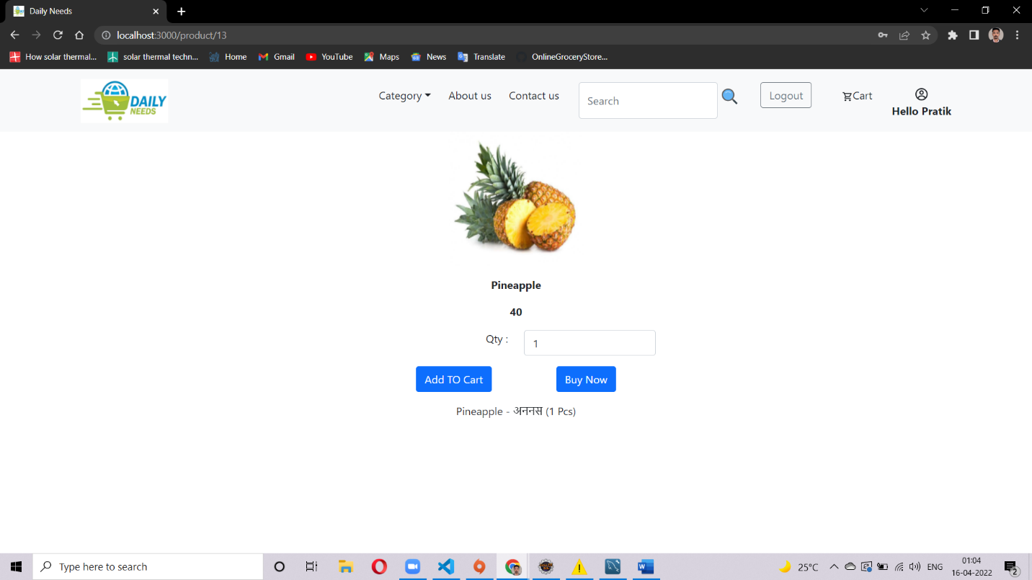

**Cart Page**

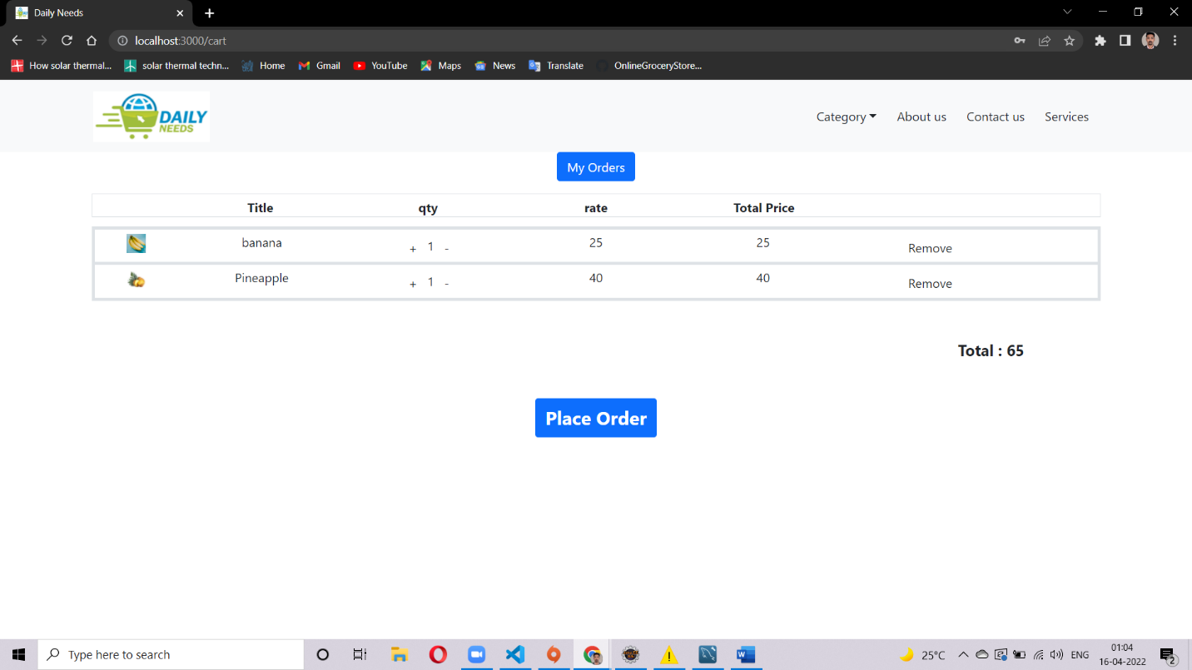

**Delivery Details Page**

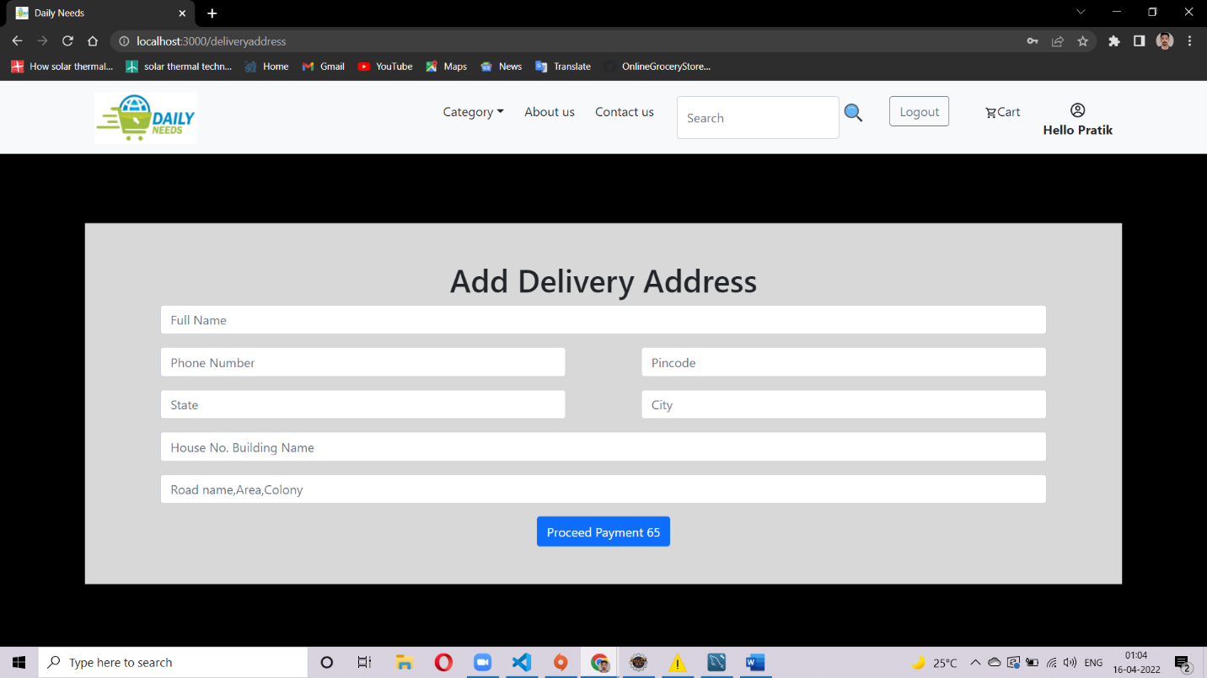

**Payment Page**

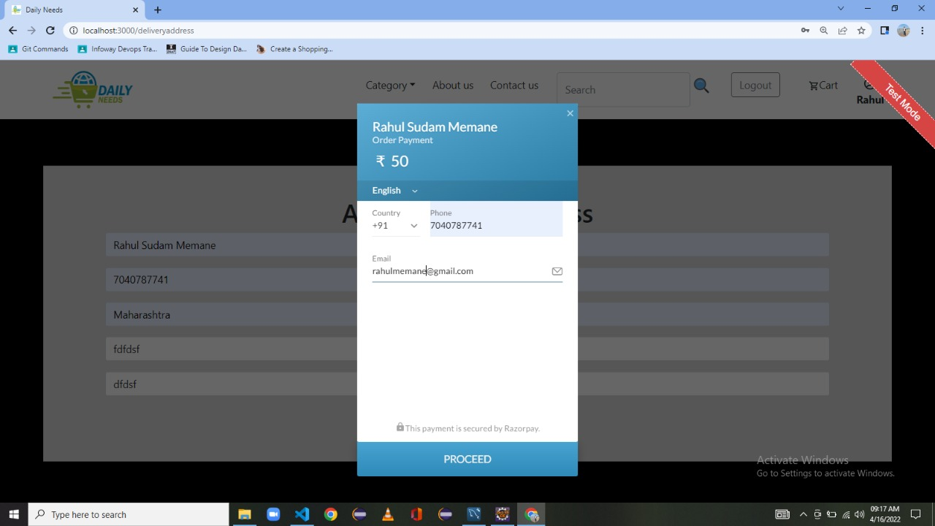

**8. Conclusion**

Our designed **Daily Needs** system provides a service, that is customers can surf the website, place orders anytime they wish to. Also, home delivery available. Some of the features that can be modified and added to this system in the future involve its implementation by local shopkeepers, where shops will be providing an online interface to customers for shopping and placing orders.

**9. Future Enhancement**

* Some delivery persons can perform their work. This will be adding on benefit for the customers as it will save their time, plus it adds on for the shopkeepers also, as people will continue to shop from local shops rather than preferring to supermarkets every time.
* Also, since the deliveries from these local vendors will not be as time-consuming as these days Flipkart, Amazon, etc. take but rather will be delivered the same day of order placed.
* Else the shopkeeper can ask the customer that the product will be available by the next day, so if he/she still wants to place the order, it can be done.
* Again, return or exchange will be easy since the delivery boy can even do it as the store is nearby.
* Including a chatbot for public benefit is also a great idea via which people can directly have a conversation with some officials regarding any type of queries.

**10.  Bibliography**

* <https://www.javatpoint.com/spring-boot-tutorial>
* <https://www.w3schools.com/REACT/DEFAULT.ASP>
* https://www.javatpoint.com/mysql-tutorial
* https://www.youtube.com/watch?v=36WoQ1anwM0